Remove parts as shown
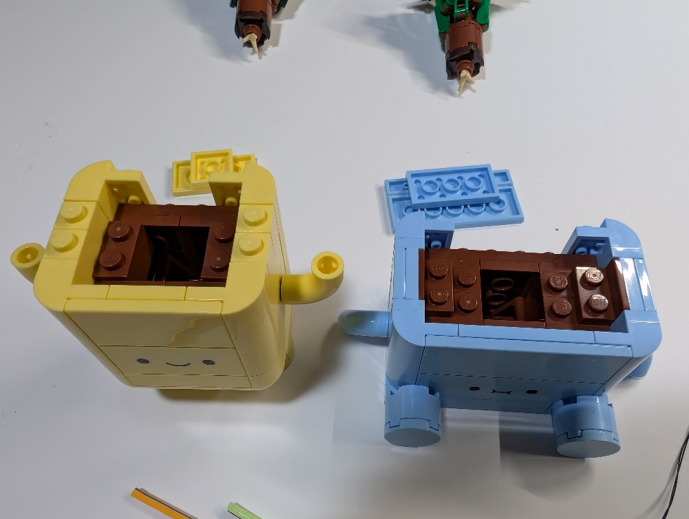
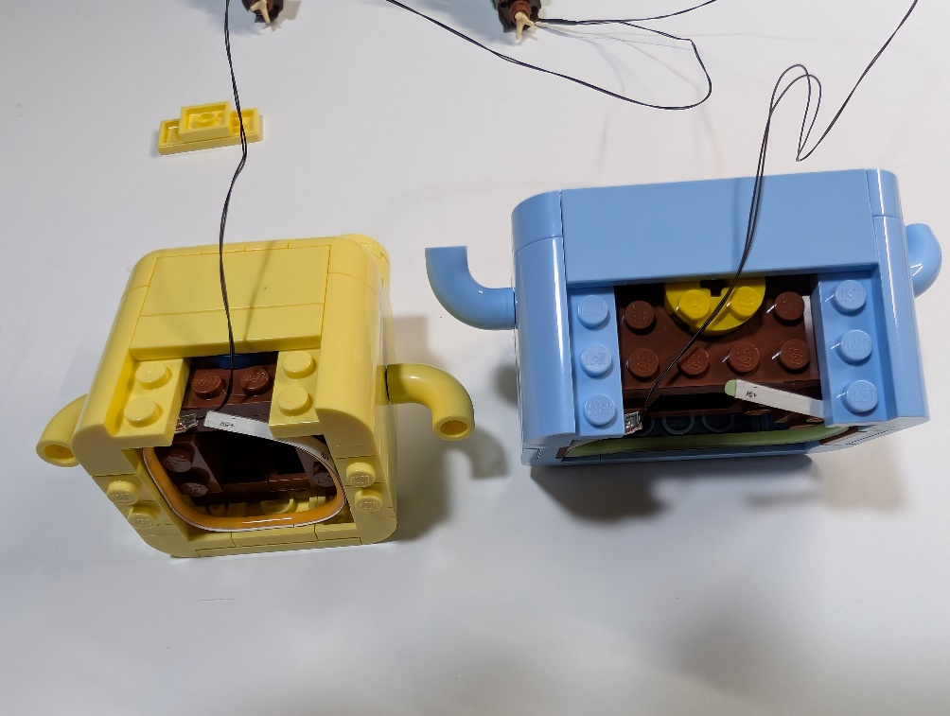
Put the yellow flex light into the yellow plant and the green (but blue light) flex light into the blue plant. You do not need to use the adhesive of the strip if you do not want to.
Ensure that the wires are not over the studs when placing the parts back.

