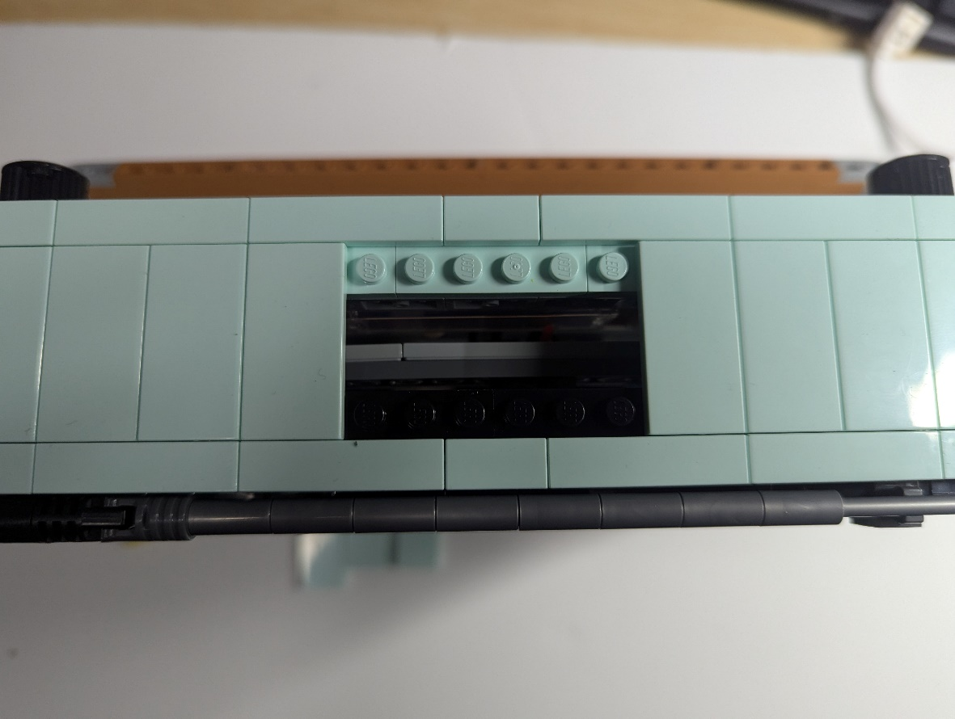  
Remove the 3 2x4 Tiles as shown above and place the 1x4 plate across the 3 Tiles as shown below.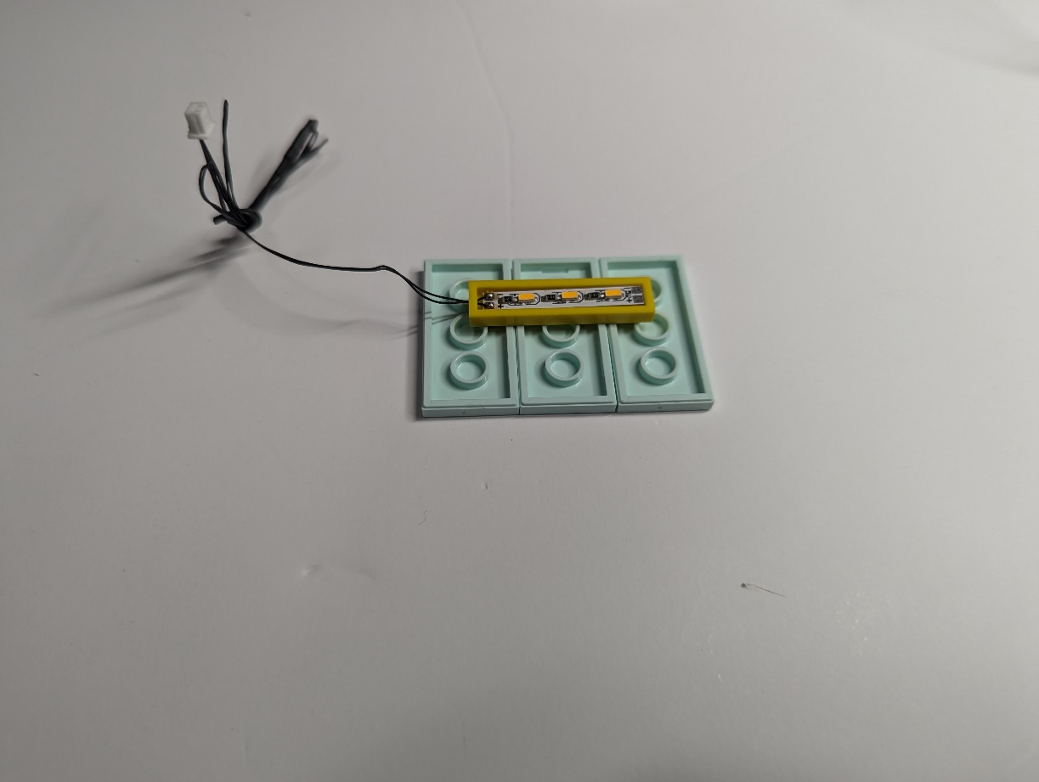

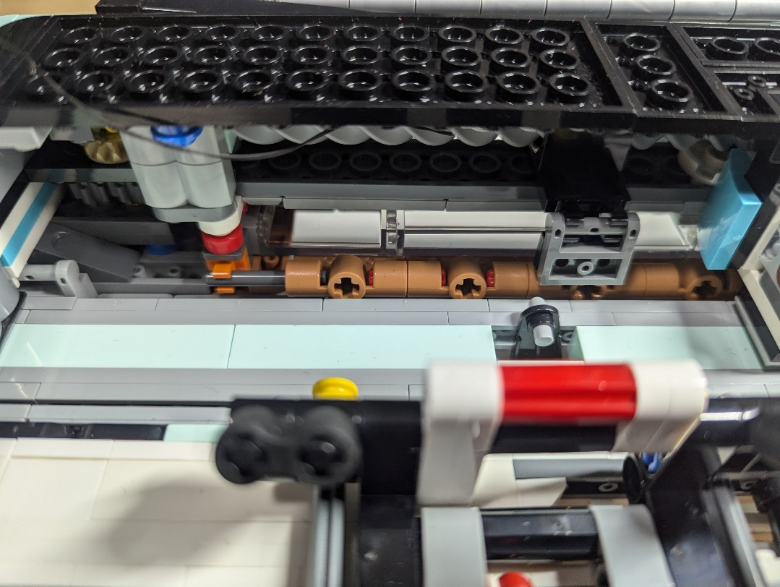  
Feed the wire down the back and behind the screw.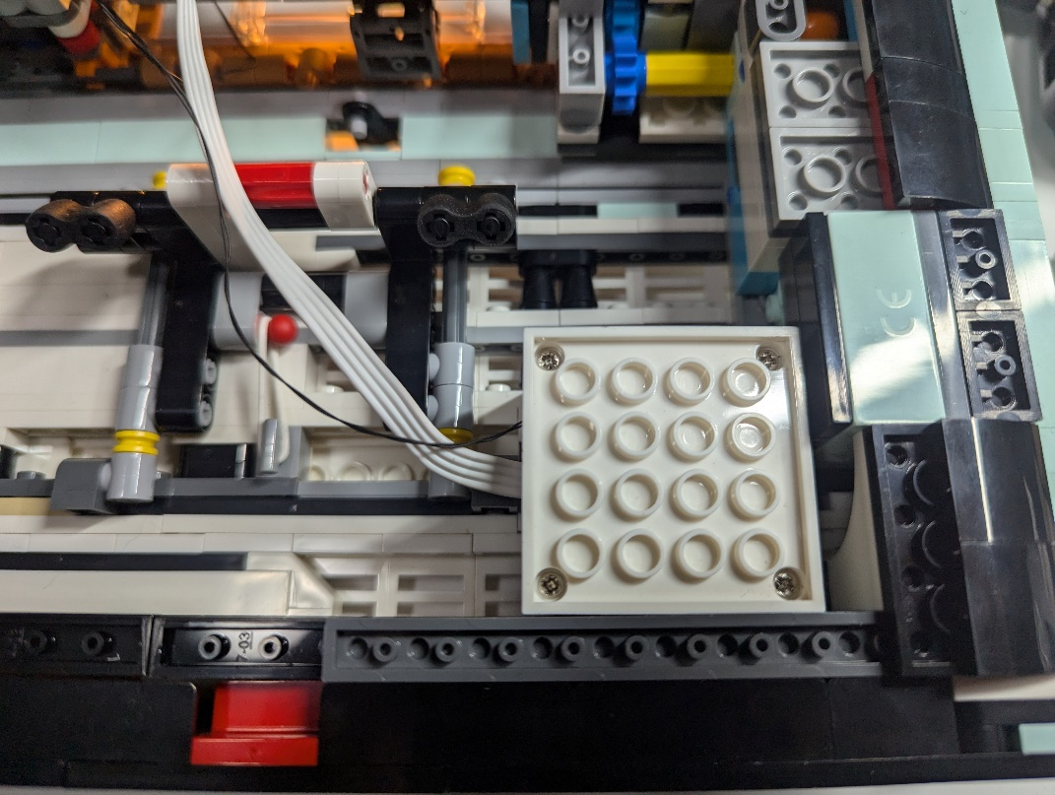  
The speaker fit here. You will need to remove any protruding parts on the backplate to allow this to sit flush.

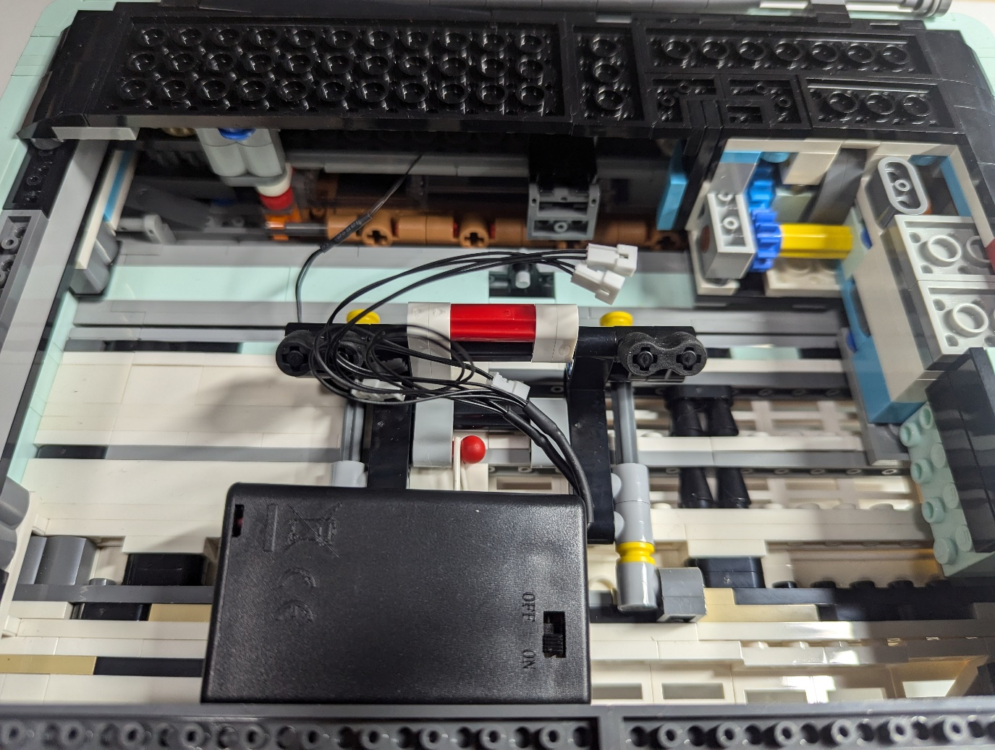  
The battery pack can sit here without any issues. Join up the plugs.  
Connect to power. You will be able to pair the speakers to any device as usual.  
JiMuYinXiang will be the name of the Bluetooth speaker.