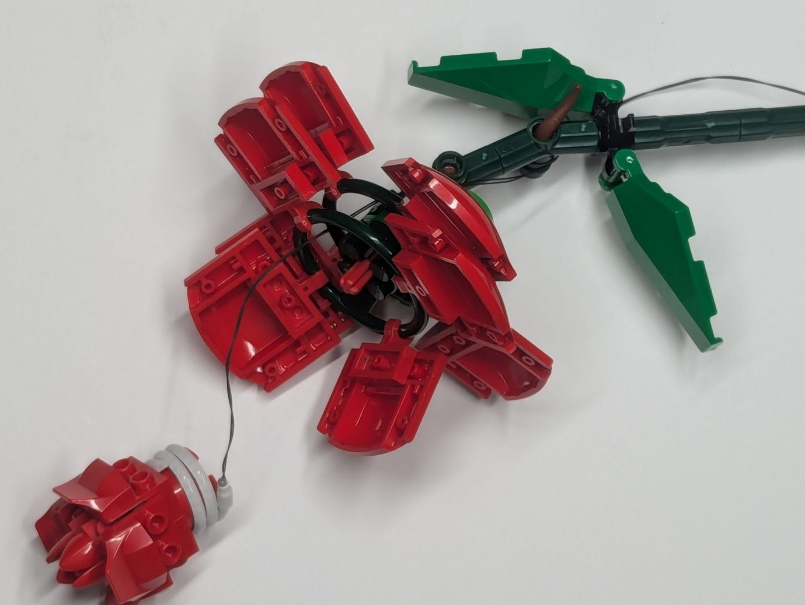  
Peel the Adhesive layer from the back of the led strip and wrap it around the 2x2 round brick. Thread the wire through the green wheel parts and connect to your chosen power source. Repeat and you are done!